First Grade Parent Handbook
Welcome to First Grade! This handbook will provide you with a quick reference about our first grade classroom policies. Please feel free to ask for clarification about any information that you have questions about or anything that was not mentioned in the handbook. I am really looking forward to partnering with you to ensure you child has a fabulous year in first grade!
Arrival
Students are not able to enter the classroom before 8:15. There is a 5 minutes warning bell that rings at 8:40 and a late bell at 8:45. If your child arrives after 8:45, you must walk your child to the front office and sign them in. The school day begins at 8:45 and school announcements will begin promptly at 8:45. It would be best if your child is in class by 8:30. Rushing in and arriving to our classroom late can get the day started in a less than positive way. We count tardy any student who is not in class by 8:45.

Dismissal and Early Dismissals
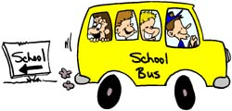
The school day ends at 3:45. Dismissal for first grade will begin at 3:45. Students will not be dismissed early after 3:15. If your child should need to be dismissed early, please go to the office to sign them out. The office will notify us and we will send your child to the office. Please send a written note that morning, so we can reassure your child that we are aware of your plans. Emails and phone calls are not accepted for dismissal changes per the front office policy.

After-school Change of Plans
Any time your child has an after-school change of plan, please send me a separate written dated note. If we do not have a note, we will send your child home the usual way. A note must be written each and every day that your child is not going home the usual way. Please do not rely on emails in lieu of notes as we may not have a chance to read emails until after school and we must have a written note for a transportation change.

Attendance
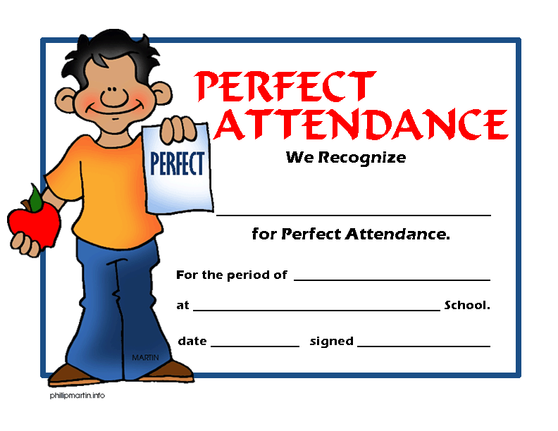
We encourage good attendance. Students should be in school every day. There is strong evidence that a direct correlation exists between good attendance and school achievement. Please try to schedule all appointments after school. On any day your child is absent, please call the school before 9:30a.m. If you have advance knowledge of an absence, please put this in writing prior to the absence. Please refer to the Davidson Elementary School Handbook for a list of excused absences. Remember to send a note indicating the date of absence and reason upon your child’s return to school.

Parent Communication
Each child will have a “Communication Folder” in their backpack each day. In this folder you should put any notes, money etc that need to come to school. The folder will also have your child’s DES spiral agenda. This agenda should stay in the pocket of the Communication Folder and be returned to school daily. You should see this folder in their backpacks each day. Please make sure it stays there.
The PTO information will be sent home electronically. Other community and school information will also come home in the Communication Folder. Grade level newsletters will be emailed monthly.
If you need to contact your child’s teacher, please either send a note with your child or leave a message in the office. You can also email us at the below addresses. We will get back with you as soon as possible. The beginnings of the school day, as well as the end of the day, are the most hectic times of the school day. Please refrain from coming to the classroom to give me messages. If your message is urgent, please contact the office! The Davidson front office phone number is (980) 343-3900.
Cindy Harrigan – cindy.harrigan@cms.k12.nc.us
Jennifer Smith – jen.smith@cms.k12.nc.us
Emily Dibble – emilya.dibble@cms.k12.nc.us
Rob Coscia – robert1.coscia@cms.k12.nc.us

Lunch
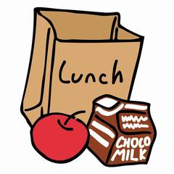
First grade lunch will be at the following times:
12:10-12:40 Harrigan & Dibble
12:15-12:45 Smith & Coscia
The cafeteria policy is that parents may eat with their children only. Students are not allowed to select friends to eat with them and their parents. Be sure to sign in at the office and get a name tag. Please meet us at the doors to the cafeteria. The cafeteria expectations this year are for children to eat quietly for the first ten minutes of lunch. Parents are also asked to assist us with this expectation. Your child’s lunch number is connected to the name tag they wear daily. You may make online deposits in your child’s account at (www.paypams.com).This will also show you exactly what your child’s been buying for lunch.

Nametags
The school will issue each child a nametag at the beginning of the school year. This name tag is used in the library to check out books and it is linked to their lunch account. Every child must wear their nametag at all times. If a child loses his/her nametag, a replacement must be made at the expense of the student, $1.00. The nametags are to stay at school. If your child comes home with nametag, please send it back to school the following day.

Birthdays
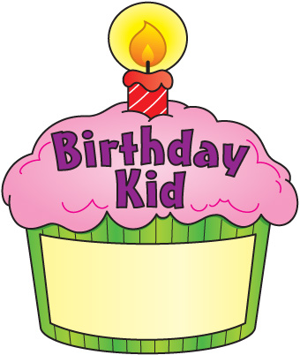
If you would like to celebrate your child’s birthday at school by bringing in a special treat please note that it is CMS policy that only store bought treats may be brought to school. Also, please refrain from bringing any products containing peanuts or peanut oil due to allergies. Lunch is the perfect time for special birthday treats, so if you would like to bring a treat for your child’s birthday please meet us in the cafeteria during our lunch time. Another fabulous way to celebrate students’ birthdays is having guest readers. If you would like to come to the classroom to read a book on your child’s birthday please let me know, we would love to have you!

Snack
Please make sure that your child has a snack every day. Send healthy snacks such as: fruit, cheese, crackers, pretzels, vegetables, popcorn, etc. No candy, cookies, beverages of any kind, or peanut products please! Since we teach good nutrition, it is important for us to practice what we preach. Snacks will not be provided for students who do not bring a snack. Students may bring in a water bottle (labeled with his/her name) to use during snack time.
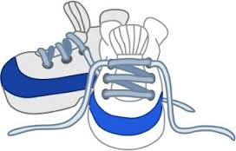
Clothing and Shoes
Bathroom accidents do occur from time to time and it is always best to be prepared. Please keep a change of clothing and underwear in a Ziploc baggie in his/her backpack. It is strongly encouraged that your child wears sneakers (or appropriate shoes for outside recess) to school every day. Students must wear sneakers on the day they have Gym. Flip-flops and open toed shoes are not appropriate for daily outdoor play.

Homework
Home Reading is without a doubt the most important daily assignment of first grade. Assignments or projects will be based on our unit themes or skills. Each Monday students will write a personal narrative. Please talk to your child about something they did over the weekend that they can write about.

Take-Home Book Baggie and Reading Log
Take-home reading will begin after assessments have been completed to determine your child’s independent reading level. Each day Monday-Friday, your child will choose one book at their just right reading level to bring home in a Take-Home Book Baggie. Your child should read this book to you to reinforce skills being learned in the classroom. In the Take-Home Book Baggie your child will also have a Reading Log. After reading, please write the title of the book or books read and sign the reading log. This reading log should always be kept inside the Take-Home Book Baggie. Your child must bring this book back to school every day in the Take-Home Book Baggie. It is very important that this book is returned each and every day. If your child does not return a book, they will no longer be able to take home books.

Daily Schedule
8:45 Arrival, Morning Procedures, Calendar
9:00 Literacy
11:05 Math
12:10 Lunch
12:50 Connect
1:45 Integrated Centers
2:30 Recess
3:20 Literacy
3:40 Dismissal

Connect Schedule
This year Davidson Elementary will be on a new, six day Connect Rotation (Days A-F). Therefore your child will not be having the same connect schedule each week. Our Connect time is 12:50-1:40. Please refer to the website for your child’s specific schedule.

Volunteers
Davidson Elementary is thankful for parent volunteers. Please note that CMS policy requires that all volunteers required steps to become an approved CMS Volunteer.
- Go to http://www.cms.k12.nc.us/
- Go to quick links and click on volunteering in CMS.
- Then click register to volunteer.
- Please fill out the form and submit online.
Volunteers are very much appreciated and a pleasure to have in the classroom. There are many ways to be involved. Please be sure to sign and return the Parent Volunteer Form! ☺

Supporting these guidelines is very much appreciated as it makes the school days go smoother and more efficiently. Let’s work together to make your child’s first grade year a success! If you have any further questions please feel free to email or call me.

First Grade Days Are Happy Days!!!!!!!

